MARKET BASKET ANALYSIS - IMAGES AND OUTPUTS
STEP 2 – LOAD DATASET
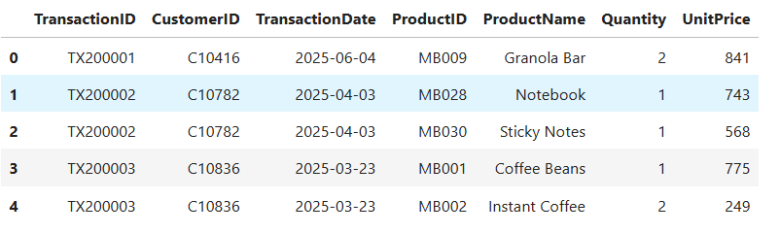
This is preview of first five rows after loading the data.
STEP 6 – EXPLORATORY DATA ANALYSIS(EDA)
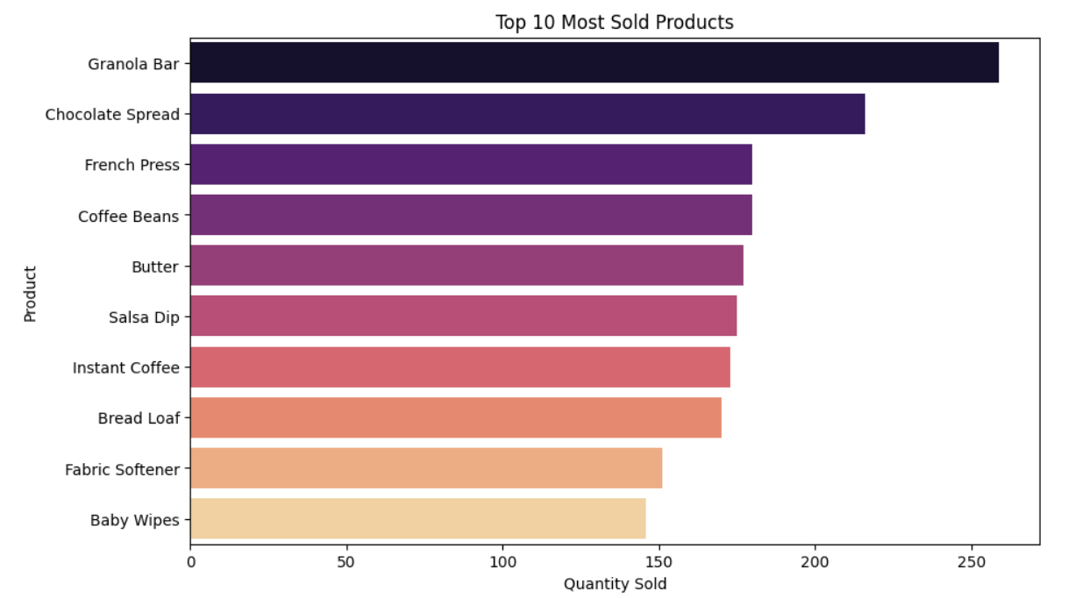
Granola Bars are the most sold product, followed by Chocolate Spread and French Press, showing strong demand for snacks and beverages. Essentials like Coffee Beans, Butter, and Bread Loaf also rank high, reflecting steady customer preference for daily use items.
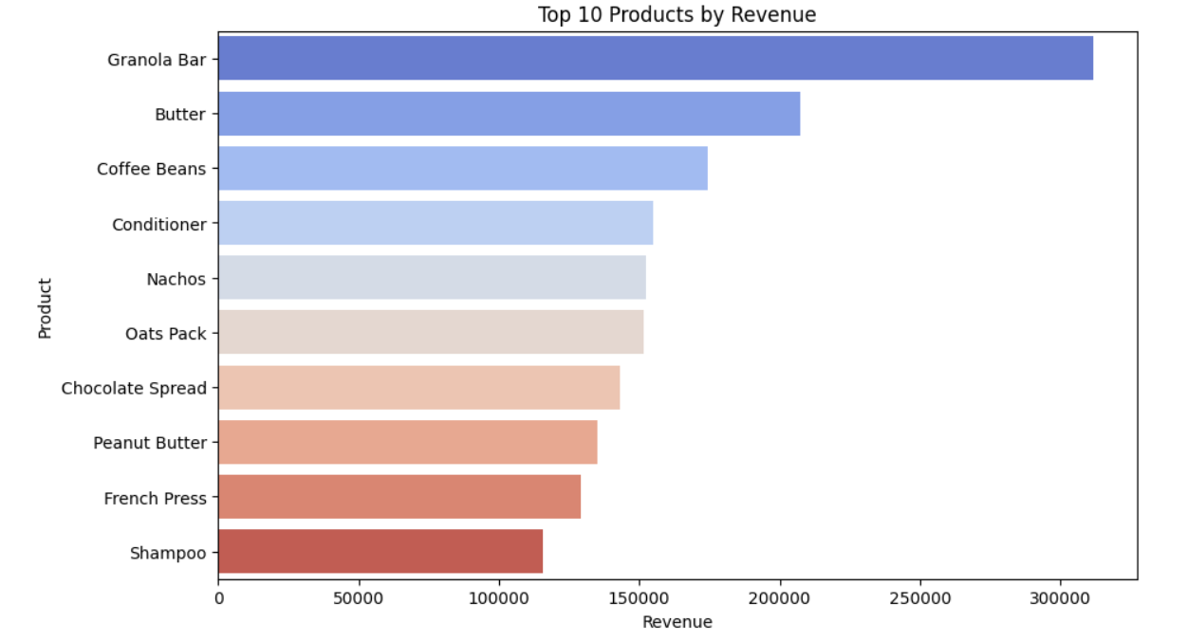
Granola Bar generates the highest revenue, followed by Butter and Coffee Beans, showing their strong contribution to overall sales. Products like Conditioner, Nachos, and Oats Pack also perform well, while Shampoo ranks lowest among the top ten. This highlights that both food staples and personal care items drive revenue.
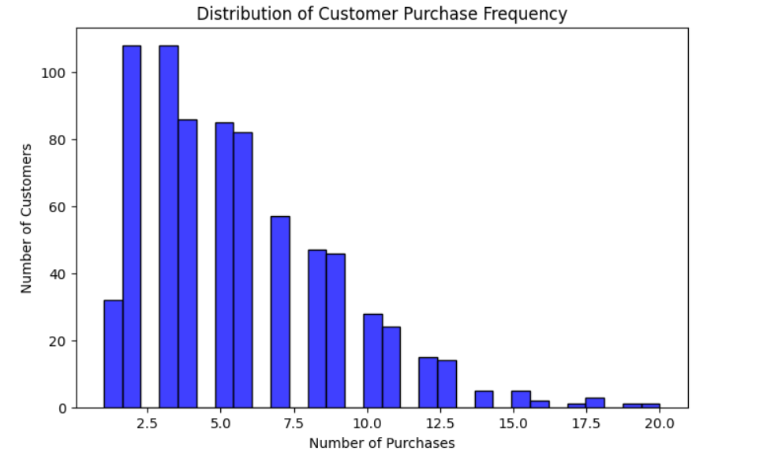
Most customers make between 2 and 5 purchases, showing that occasional buyers dominate the dataset. As the number of purchases increases, the count of customers steadily decreases, meaning frequent buyers are fewer but more valuable.
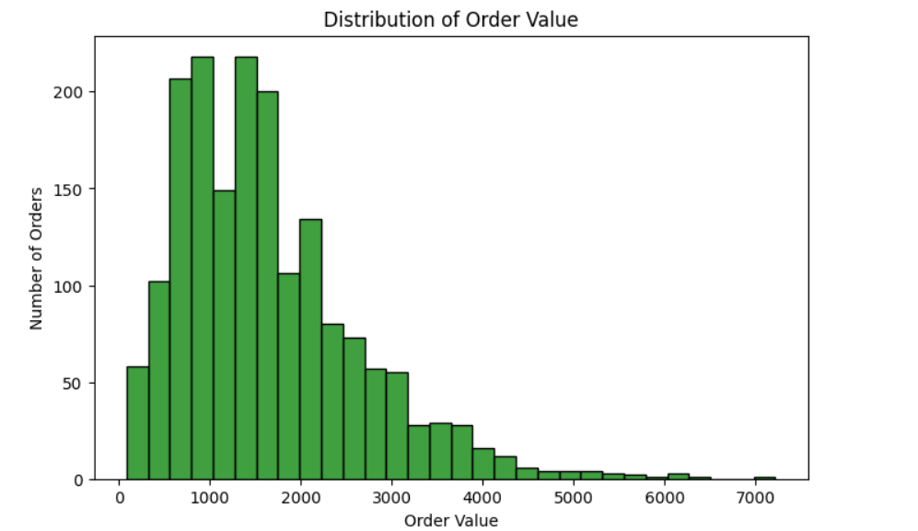
Most orders fall between 500 and 2000 in value, showing that lower-value purchases are the most common. As order value increases beyond 3000, the number of orders drops sharply, meaning high-value transactions are rare compared to everyday purchases.
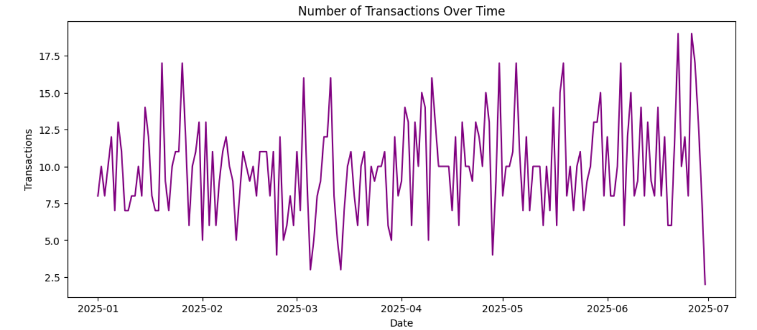
The graph shows that transaction levels fluctuate across the first half of 2025, with some peaks and drops over time. This indicates varying customer activity, where certain periods had higher sales while others experienced lower engagement.

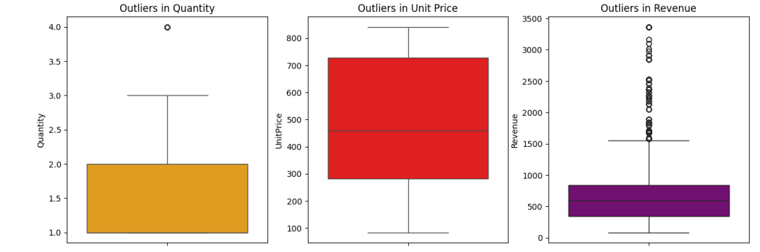
The box plots show that Quantity has a small outlier, Unit Price is fairly consistent with no major outliers, while Revenue has many high outliers above 1500. This means revenue values vary widely compared to stable unit prices, and extreme sales amounts occur more often.
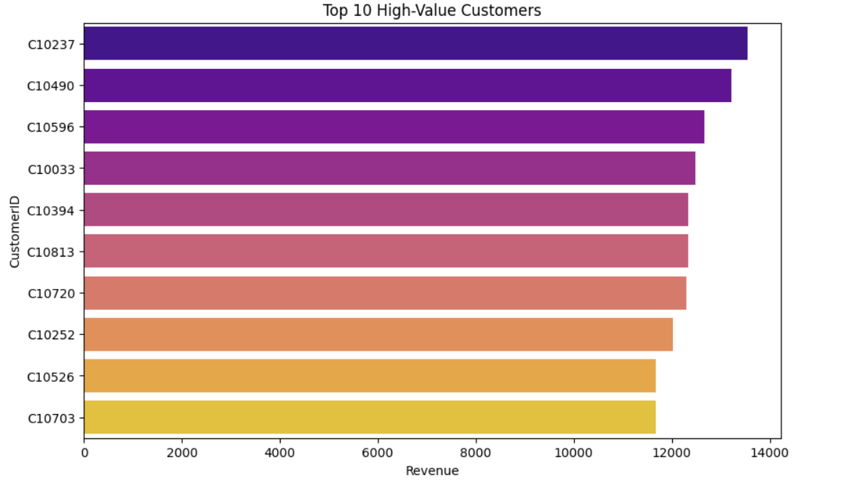
The chart highlights the top customers who contribute the most revenue, with IDs like C10237 and C10490 leading the list. These high-value customers are crucial for business growth, as they generate significantly more sales compared to others.
STEP 7 - TRANSACTION BASKET PREPARATION
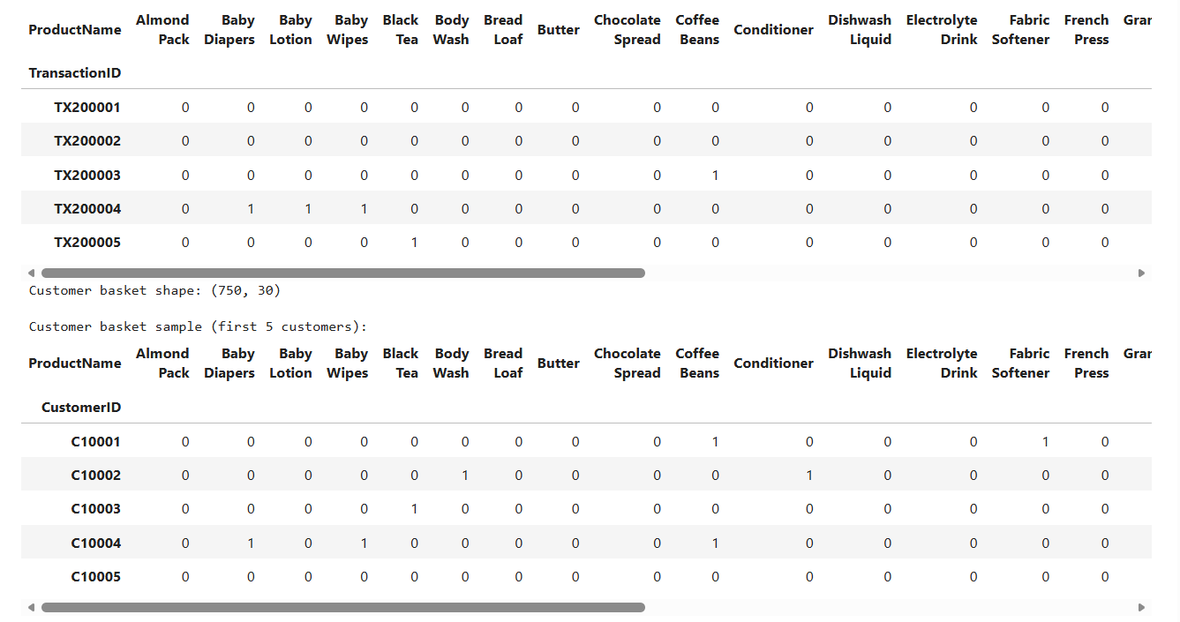
The tables show how customer transactions are encoded with 0s and 1s, where 1 means a product was purchased. Most baskets contain a mix of daily essentials like Bread, Butter, and Coffee Beans, while some include baby or household items. This structure helps analyze purchase patterns and generate association rules.
STEP 8 – FREQUENT ITEMSET GENERATION
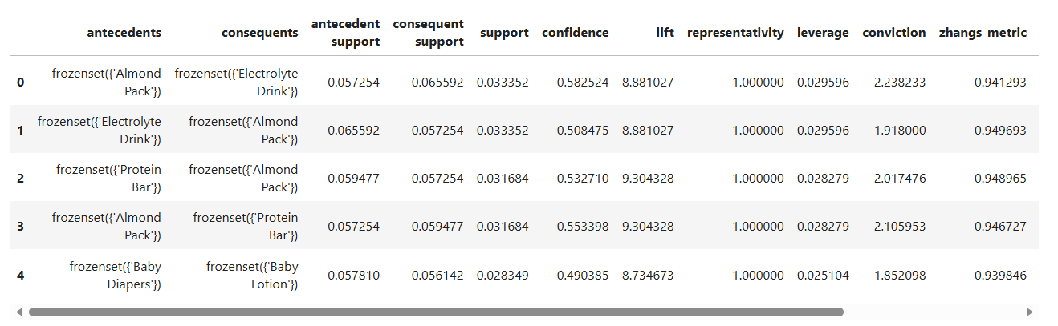
The rules show strong product relationships, such as Almond Pack with Electrolyte Drink and Protein Bar, with high lift values above 8. This means these items are often bought together and can be bundled or cross-sold. Similarly, Baby Diapers and Baby Lotion form a clear pair, reflecting customer preference for related baby products.
STEP 11 – BUSINESS RECOMMENDATIONS
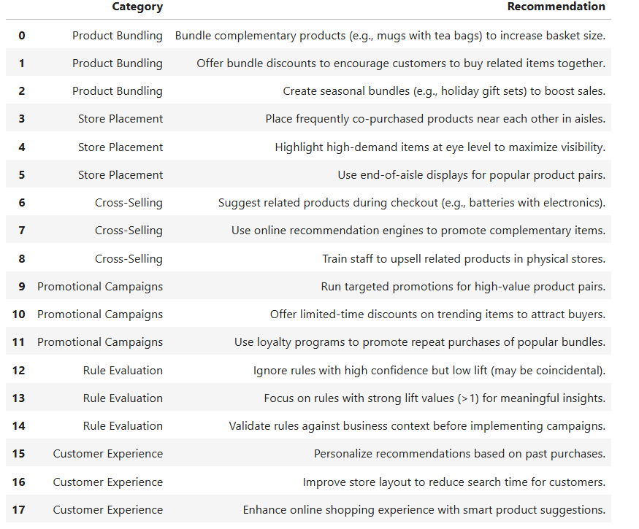
The table summarizes practical strategies like bundling complementary products, placing related items together in stores, and using cross-selling at checkout. It also highlights promotional campaigns, rule evaluation, and customer experience improvements, showing how association rules can be applied to boost sales and engagement.

